Jahnvi Pael

2024-01-23

library(dplyr)

library(ggplot2)  
library(caret)

# Load train and test datasets  
train_data <- read.csv("adm_train.csv")  
test_data <- read.csv("adm_test.csv")

# Explore the data  
str(train_data)

## 'data.frame': 249 obs. of 9 variables:  
## $ Serial.No. : int 1 2 3 4 5 6 7 8 9 10 ...  
## $ GRE.Score : int 337 324 316 322 314 330 321 308 302 323 ...  
## $ TOEFL.Score : int 118 107 104 110 103 115 109 101 102 108 ...  
## $ University.Rating: int 4 4 3 3 2 5 3 2 1 3 ...  
## $ SOP : num 4.5 4 3 3.5 2 4.5 3 3 2 3.5 ...  
## $ LOR : num 4.5 4.5 3.5 2.5 3 3 4 4 1.5 3 ...  
## $ CGPA : num 9.65 8.87 8 8.67 8.21 9.34 8.2 7.9 8 8.6 ...  
## $ Research : int 1 1 1 1 0 1 1 0 0 0 ...  
## $ Chance.of.Admit : num 0.92 0.76 0.72 0.8 0.65 0.9 0.75 0.68 0.5 0.45 ...

summary(train_data)

## Serial.No. GRE.Score TOEFL.Score University.Rating SOP   
## Min. : 1 Min. :290.0 Min. : 93.0 Min. :1.000 Min. :1.00   
## 1st Qu.: 63 1st Qu.:310.0 1st Qu.:104.0 1st Qu.:2.000 1st Qu.:3.00   
## Median :125 Median :318.0 Median :108.0 Median :3.000 Median :3.50   
## Mean :125 Mean :317.6 Mean :108.3 Mean :3.249 Mean :3.54   
## 3rd Qu.:187 3rd Qu.:326.0 3rd Qu.:112.0 3rd Qu.:4.000 3rd Qu.:4.50   
## Max. :249 Max. :340.0 Max. :120.0 Max. :5.000 Max. :5.00   
## LOR CGPA Research Chance.of.Admit   
## Min. :1.500 Min. :6.800 Min. :0.0000 Min. :0.3400   
## 1st Qu.:3.000 1st Qu.:8.200 1st Qu.:0.0000 1st Qu.:0.6400   
## Median :3.500 Median :8.640 Median :1.0000 Median :0.7300   
## Mean :3.546 Mean :8.641 Mean :0.5582 Mean :0.7284   
## 3rd Qu.:4.000 3rd Qu.:9.100 3rd Qu.:1.0000 3rd Qu.:0.8500   
## Max. :5.000 Max. :9.920 Max. :1.0000 Max. :0.9700

# Renamed columns  
colnames(train_data) <- c("Serial No", "GRE", "TOEFL", "University Rating", "SOP", "LOR", "CGPA", "Research", "Chance of Admit")  
colnames(test_data) <- c("Serial No", "GRE", "TOEFL", "University Rating", "SOP", "LOR", "CGPA", "Research", "Chance of Admit")

any_missing_train <- any(is.na(train_data)) # there are no missing values in the entire train_data data set.  
any_missing_test <- any(is.na(test_data)) # there are no missing values in the entire test_data data set.

# Detecting Outliers  
# Boxplot for Score  
boxplot(train_data$GRE, main = "Boxplot of GRE")

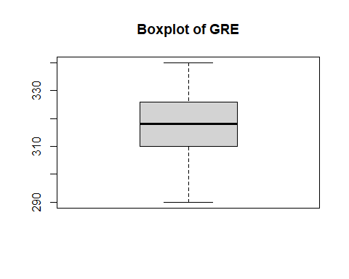

boxplot(train_data$TOEFL, main = "Boxplot of TOEFL")

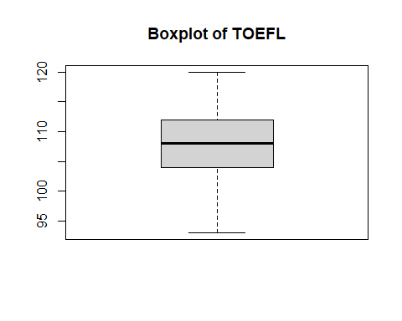

boxplot(train_data$CGPA, main = "Boxplot of CGPA")

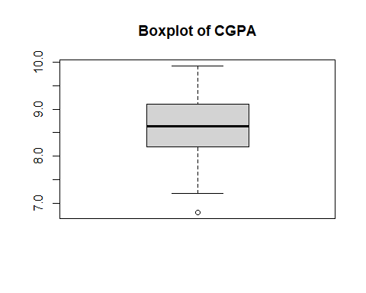

# Identifying outliers using z-score  
z_scores <- scale(train_data$CGPA)  
outliersCGPA <- which(abs(z_scores) > 3) # outlier detected at 59

# Imputed outlier with the median of CGPA directly in the same column  
train_data$CGPA[abs(z_scores) > 3] <- median(train_data$CGPA, na.rm = TRUE)

#Checking Data Distribution  
# Histogram   
hist(train_data$CGPA, main = "Histogram of CGPA", col = "lightblue")

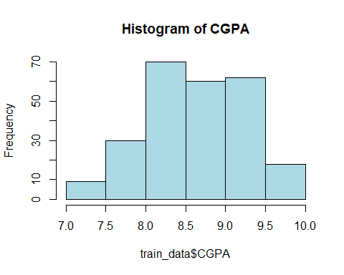

hist(train_data$GRE, main = "Histogram of GRE", col = "blue")

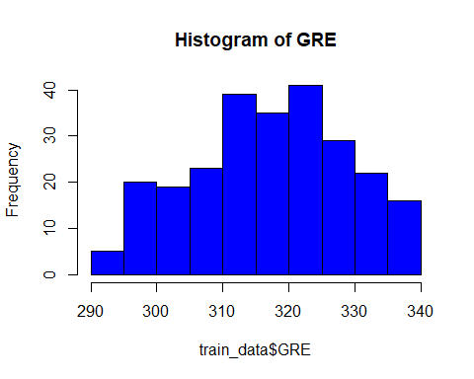

hist(train_data$TOEFL, main = "Histogram of TOEFL", col = "green") # doesn't feel like data is highly skewed.

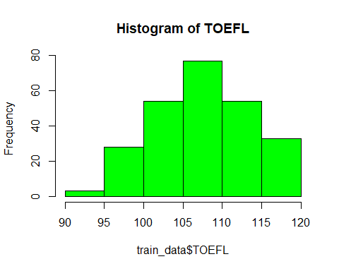

# Visualizing Correlations  
# Correlation matrix  
train_correlation_matrix <- cor(train_data[, c("GRE", "TOEFL", "CGPA", "Research", "Chance of Admit")])

# Create a heatmap using corrplot  
library(corrplot)

corrplot(train_correlation_matrix, method = "number", col = colorRampPalette(c("white", "blue", "red"))(100), number.cex = 0.7)

# This approach can be helpful when the color differences are not very pronounced

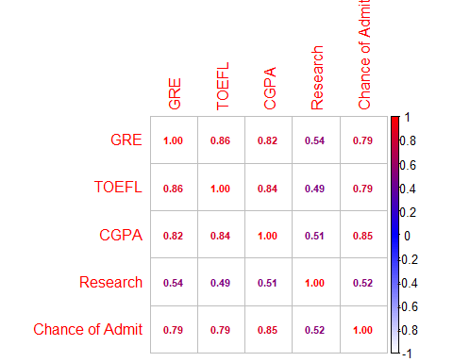

# Multiple correlations using the psych package  
library(psych)

pairs.panels(train_data[, c("GRE", "TOEFL", "CGPA")])

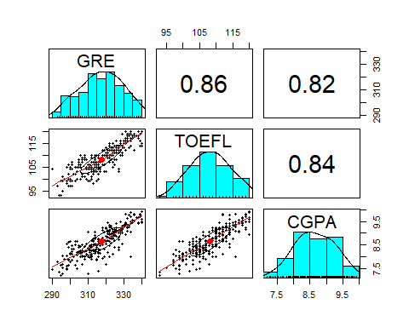

# Scatter plot of GRE vs. CGPA  
library(ggplot2)  
ggplot(train_data, aes(x = GRE, y = CGPA, color = `Chance of Admit`)) +  
 geom_point() +  
 geom_smooth(method = "lm", se = FALSE, color = "blue") +  
 labs(title = "Scatter Plot of GRE vs. CGPA") +  
 scale_color_gradient(low = "blue", high = "red")

## `geom_smooth()` using formula = 'y ~ x'

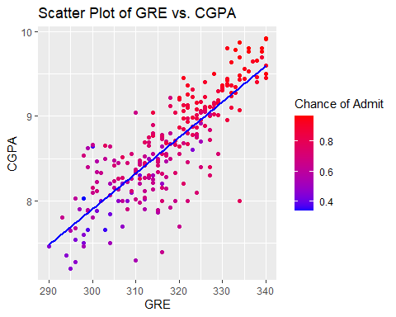

# Scatter Plot of TOEFL vs. CGPA  
ggplot(train_data, aes(x = TOEFL, y = CGPA, color = `Chance of Admit`)) +  
 geom_point() +  
 geom_smooth(method = "lm", se = FALSE, color = "blue") +  
 labs(title = "Scatter Plot of TOEFL vs. CGPA") +  
 scale_color_gradient(low = "blue", high = "red")

## `geom_smooth()` using formula = 'y ~ x'

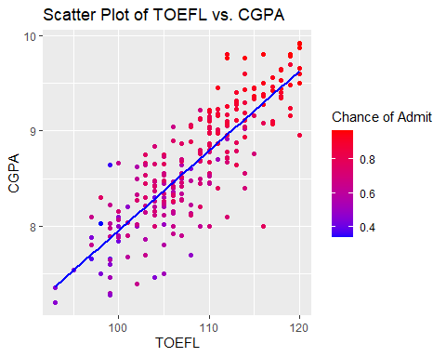

# Scatter Plot of GRE vs. TOEFL  
ggplot(train_data, aes(x = GRE, y = TOEFL, color = `Chance of Admit`)) +  
 geom_point() +  
 geom_smooth(method = "lm", se = FALSE, color = "blue") +  
 labs(title = "Scatter Plot of GRE vs. TOEFL") +  
 scale_color_gradient(low = "blue", high = "red")

## `geom_smooth()` using formula = 'y ~ x'

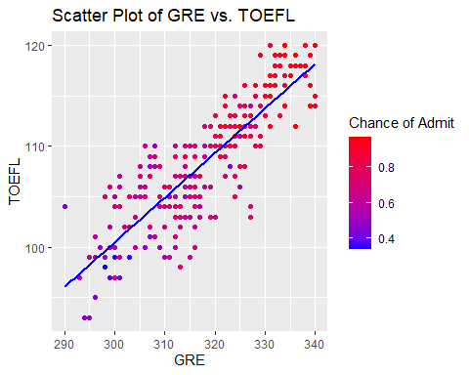

# Linear regression model  
model <- lm(`Chance of Admit` ~ GRE + TOEFL + CGPA + Research, data = train_data)

# Model evaluation  
predictions <- predict(model, newdata = test_data)  
actual_outcomes <- test_data$`Chance of Admit`  
mse <- mean((actual_outcomes - predictions)^2)

# Saved predictions to a CSV file  
predictions_df <- data.frame(Chance_of_Admit_Predicted = predictions)  
write.csv(predictions_df, "predicted_results.csv", row.names = FALSE)

Linear regression model equation:   
  
Chance of Admit = -1.5810856 + 0.0024593 * GRE + 0.0033339 * TOEFL + 0.1335526 * CGPA + 0.0221002 * Research

Coefficients:

* Intercept: The intercept is -1.5810856.
* GRE: The coefficient for GRE is 0.0024593, indicating that for a one-unit increase in GRE, the chance of admission increases by this amount.
* TOEFL: The coefficient for TOEFL is 0.0033339, suggesting a similar interpretation as GRE.
* CGPA: The coefficient for CGPA is 0.1335526, implying that a one-unit increase in CGPA is associated with a 0.1335526 increase in the chance of admission.
* Research: The coefficient for Research is 0.0221002, suggesting that having research experience increases the chance of admission by this amount.
* Significance Levels: The significance levels are denoted by the p-values. Variables with p-values less than 0.05 (indicated by **, *, or .) are considered statistically significant. In this model, Intercept, GRE, CGPA are statistically significant, while TOEFL and Research have p-values close to the significance level. Model Fit:
* Residual standard error: It measures the average amount that the predicted values differ from the actual values. In this case, it is 0.07444.
* Multiple R-squared: It represents the proportion of the variance in the dependent variable (Chance of Admit) that is predictable from the independent variables (GRE, TOEFL, CGPA, Research). Here, it is 0.7542, indicating a good fit.
* Adjusted R-squared: It adjusts the R-squared for the number of predictors in the model. It is 0.7501.
* F-statistic and p-value: These assess the overall significance of the model. A low p-value (< 0.05) suggests that at least one variable is significant in predicting the dependent variable.

In summary, the model suggests that GRE, CGPA, and having research experience are statistically significant predictors of the chance of admission. The model also has a good overall fit based on R-squared and F-statistic.